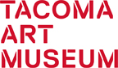
MEDIA RELEASE
August 31, 2016
Media Contact: Julianna Verboort, 253-272-4258 x3011 or JVerboort@TacomaArtMuseum.org
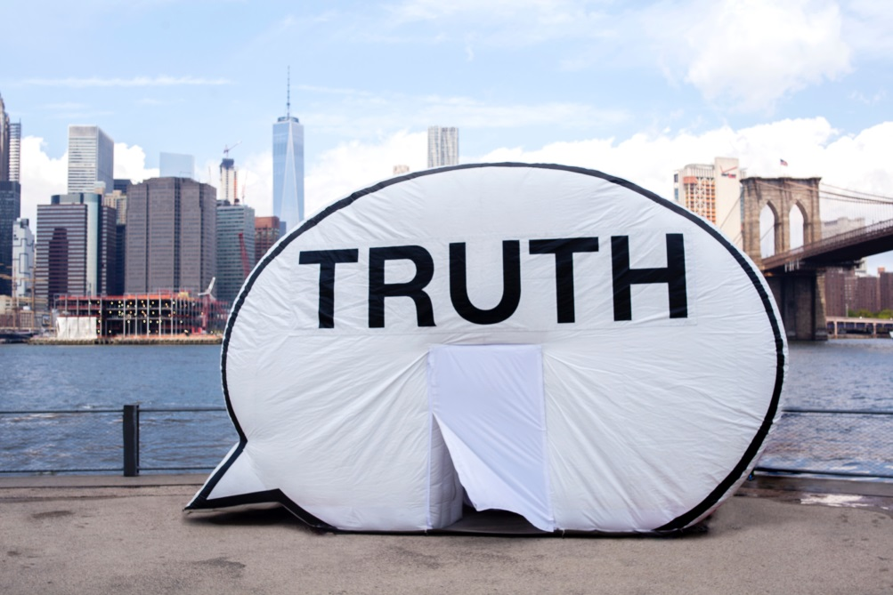
The Truth Booth makes a flash appearance at Tacoma Art Museum on September 6
In search of the truth? Want to speak your own truth? Pop in to The Truth Booth at Tacoma Art Museum (TAM) on Tuesday, September 6, 2016 from 10 am to 5 pm. The Truth Booth is a project by members of The Cause Collective. It is touring 24 U.S. cities through 2016 as part of their project In Search of The Truth (The Truth Booth). At each location, The Collective invites people to sit inside The Truth Booth (a giant, inflatable sculpture in the shape of a cartoon speech bubble with the word “Truth” printed on the side) and complete the sentence, “The truth is…” while being videotaped. The events are free and open to the public.
The Truth Booth is the brainchild of Ryan Alexiev, Jim Ricks, Will Sylvester, and Hank Willis Thomas. Operating as a team of artists, designers and ethnographers, they work to bring thoughtful, interactive and engaging projects into local communities here and abroad. In this project, they are particularly interested in transforming public spaces into sites for candor and intimacy. The Collective aims to empower hundreds of Americans to speak freely without fear of judgment or persecution. While everyone seeks the truth, two people rarely arrive at the same interpretation, which is why the project’s prompt of “The truth is…” is so powerful and revealing.
For TAM, the project coincides nicely with the upcoming exhibition 30 Americans, opening at TAM on September 24. Hank Willis Thomas will also have work on view in 30 Americans. TAM’s Director of Education Samantha Kelly said, “We are thrilled The Truth Booth chose Tacoma Art Museum for its Washington State appearance. The Cause Collective shares our mission of connecting people through art. We are eager for this artwork to engage our audiences and inspire meaningful dialogue around people’s truths.”
The ideas behind The Truth Booth began during a 2006 Cause Collective project entitled The Truth is I am You, in which the artists flew giant inflatable sculptures in the shape of cartoon speech bubbles above the Socrates Sculpture Garden in Long Island, New York. In 2008, a 300-foot sculpture by the Cause Collective was permanently installed at the University of California, San Francisco (UCSF). It is comprised of speech bubbles containing a single line of a poem by Hank Willis Thomas and Ryan Alexiev, each of which begins with the phrase “The truth is…” translated into alternating languages spoken by the student body of UCSF.
“The Truth Booth offers TAM a unique opportunity to participate in the Cause Collective’s creative process. The complicated and provocative prompt about each person’s insight into truth will reveal how we shape contemporary society,” observed TAM’s Chief Curator Rock Hushka.
The Cause Collective launched The Truth Booth in 2011 at the Galway Arts Center in Galway, Ireland and over that summer toured the country extensively. The project has since traveled to Afghanistan and Cape Town, South Africa. Within the US, The Truth Booth events have taken place in Charlottesville, VA, Long Island, NY (for the 2012 Presidential Debate at Hofstra University), Washington, D.C., Cleveland, OH, Palo Alto, CA, Menlo Park, CA, Black Rock, NV, Miami Beach, FL (for Art Basel), Chicago, IL, Brooklyn, NY, and Boston, MA.
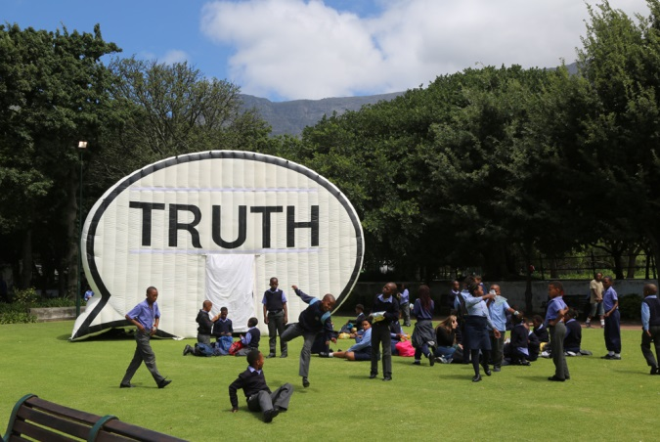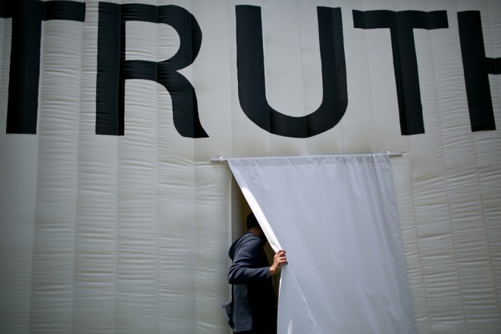
# # #
Image Credits:
Photo courtesy of The Cause Collective.

The Truth Booth tour media contact: Hannah Holden, Olu & Company, (714) 655–3839, hannah@olucompany.com

About The Cause Collective
Hank Willis Thomas is a photo conceptual artist working primarily with themes related to identity, history and popular culture. He received a BFA in Photography and Africana studies from New York University and his MFA/MA in Photography and Visual Criticism from the California College of Arts. His work is featured in the collections of the Museum of Modern Art, the Guggenheim Museum, and the Oakland Museum of California. He has exhibited at the Smithsonian National Museum of American History, and the High Museum of Art, among others. He is represented by Jack Shainmen Gallery and Goodman Gallery.
Raised in Alaska by Bulgarian immigrants, Ryan Alexiev received a BA in History from the University of California at Berkeley and an MFA from the California College of the Arts, where he currently teaches in the Graduate Design program. He has exhibited at galleries across the country including the Andy Warhol Museum, Wadsworth Atheneum, the Nathan Cummings Foundation, and the Armory Show in New York, and the Oakland Museum of California. Ryan is also co-founder of the Cause Collective which was commissioned to create The Truth is I Am You for the University of California at San Francisco and the video installation Along the Way for the Oakland International Airport. Along the Way went on to feature at the 2008 Sundance Film Festival.
Jim Ricks studied at the National University of Ireland, Galway/Burren College of Art and the California College of the Arts. Originally from California, he moved to Ireland in 2005 to become an artist. Ricks was selected for Futures 12 at the Royal Hibernian Academy in 2012. In the last two years Ricks has created and toured the popular public work The Poulnabrone Bouncy Dolmen. Alongside solo shows at Pallas Projects, The Black Mariah, and the Dublin City Gallery The Hugh Lane. He has curated shows in Dublin, London, Galway and San Francisco.
Will Sylvester received a BA with a concentration on Documentary Film for Social and Cultural Change from the University of Massachusetts in 2011. That same year he went on to edit, build and tour the Question Bridge: Black Males exhibition, including showings at Sundance Film Festival’s New Frontiers and the Shefﬁeld Documentary Film Festival. As a member of the Cause Collective, Will helped to create The Long March, a 27-monitor installation incorporating depictions of movement, migration and marching from different eras in Alabama history. Will has also served as supervising editor for several projects including “Am I Going Too Fast,” “A person is worth more than anything else…” and “We are not yet free….”
About Tacoma Art Museum
Celebrating 80 years, Tacoma Art Museum is an anchor in the city’s downtown and a gathering space for connecting people through art. TAM’s collection contains nearly 5,000 works, with an emphasis on the art and artists of the Northwest and broader western region. The collection includes the largest retrospective museum collection of glass art by Tacoma native Dale Chihuly on continuous view; the most significant museum collection of jewelry by Northwest artists; key holdings in 19th century European and 20th century American art; and one of the finest collections of Japanese woodblock prints on the West Coast. In 2014, TAM welcomed a gift of 295 works of western American art in the Haub Family Collection, one of the premier collections in the nation and the first major western American art museum collection in the Northwest. The Haub gift included $20 million for new galleries and endowed funds. The Haub Family Galleries opened in 2014. In January 2016, TAM announced the gift of the Benaroya Collection, including 225 works of art. The donation also includes nearly $14 million in funding for new gallery space to showcase the collection and an endowment for a dedicated curator and care for the collection. The Benaroya wing is expected to open in fall 2018.
HOURS – Tuesdays–Sundays 10 am–5 pm, Third Thursdays 10 am–8 pm; Third Thursdays free from 5-8 pm.
ADMISSION – Adult $15, Student/Military/Senior (65+) $13, Family $40 (2 adults and up to 4 children under 18). Children 5 and under free. Members always free.
CONTACT – 253-272-4258, www.TacomaArtMuseum.org, info@TacomaArtMuseum.org

