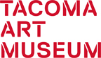

MEDIA RELEASE
January 5, 2017
Media Contact: Julianna Verboort, 253-272-4258 x3011 or JVerboort@TacomaArtMuseum.org
The Outwin 2016: American Portraiture Today from the Smithsonian’s National Portrait Gallery is coming to Tacoma Art Museum
First time ever, only West Coast location
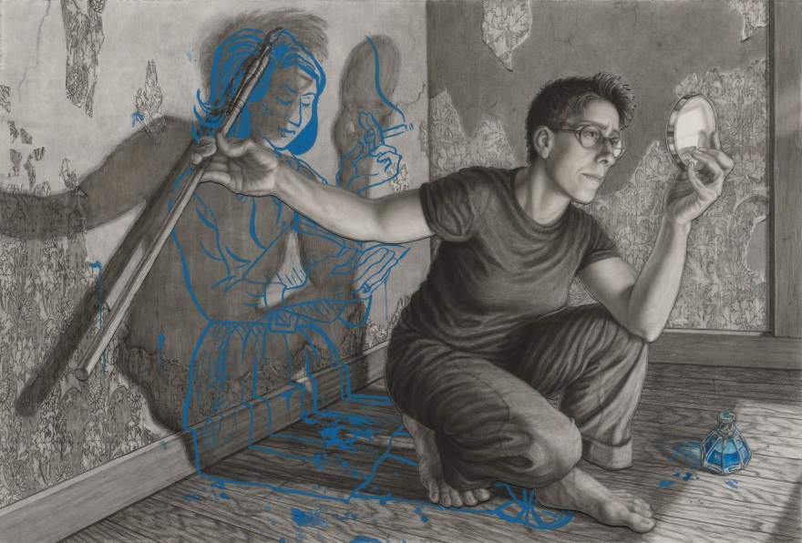
Tacoma, WA – The Outwin 2016: American Portraiture Today, the exhibition resulting from the triennial Outwin Boochever Portrait Competition at the Smithsonian’s National Portrait Gallery, will open at Tacoma Art Museum on Saturday, February 4, 2017. The exhibition features 43 innovative works in the art of portrayal including paintings, sculpture, drawings, photographs, and mixed-media installations. The dazzling variety of media and diverse approaches to exploring “self” and “other” will challenge preconceived notions of portraiture and expand visitors’ imaginations. The exhibition will be on view through Mother’s Day, Sunday, May 14, 2017.
The Outwin 2016 has been one of the Portrait Gallery’s most popular shows, drawing more than 900,000 visitors to their Washington, D.C. galleries. The exhibition features finalists from the competition’s fourth iteration. More than 2,500 artists from across the United States submitted entries. The Outwin 2016’s appearance at Tacoma Art Museum (TAM) presents a rare opportunity for art lovers as this is the first time that the show has traveled beyond the Portrait Gallery. TAM will be the first stop on the national tour and the only West Coast location.
“The Outwin 2016: American Portraiture Today showcases national conversations from the past three years,” said Kim Sajet, Director of the National Portrait Gallery, who will speak at TAM’s Members’ Opening Celebration on the evening of February 4. “These works not only are geographically diverse, they also reflect discussions around gender, race, poverty, healthcare, at-risk youth, migration and the power of family.”
The exhibition includes both English and Spanish gallery labels. Visitors will be able to vote for their favorite portrait, and watch a video featuring interviews with the top prize-winning artists and guest jurors. An exhibition catalogue illustrating each of the 43 finalists’ works will be available in the TAM Store for $14.95. Special events mark the opening day including a Curator Conversation at 3 pm with Dorothy Moss, Associate Curator of Painting and Sculpture at the National Portrait Gallery. Moss will talk about the competition’s history, and how the six judges went about selecting finalists from the thousands of entries. During the run of the exhibition, visitors can participate in a Portrait Party free community festival, artists talks, free Third Thursday gallery access and activities, and interactive social media opportunities.
“We are thrilled to have the opportunity to bring the Smithsonian’s exhibition to TAM and to the region. It is a great fit for many reasons. Portraiture is one of TAM’s collecting strengths. Portraits carry meaning that everyone can relate to. And it is a significant area of practice for many Northwest artists,” said Stephanie Stebich, Executive Director at TAM. “The Outwin 2016 brings a selection of the most exceptional and exciting works in portraiture from across our country. These portraits tell stories of national concerns that resonate in Tacoma, too. We look forward to sharing it with everyone.”
Noted guest jurors for the competition included Dawoud Bey, professor of art and a Distinguished College Artist at Columbia College in Chicago; Helen Molesworth, chief curator at Museum of Contemporary Art, Los Angeles; Jerry Saltz, senior art critic at New York magazine; and John Valadez, a Los Angeles–based realist painter and muralist. Portrait Gallery staff on the jury were Brandon Brame Fortune, chief curator, and Dorothy Moss, associate curator of painting and sculpture and competition director. The jurors considered this exhibition a synopsis of historical and cultural events that have unfolded in the past three years (since the previous competition).
First prize went to artist Amy Sherald of Baltimore, MD, for an oil on canvas titled Miss Everything (Unsuppressed Deliverance). Sherald received $25,000 and a commission to create a portrait of a living individual for the Portrait Gallery’s permanent collection. Second prize was awarded to Cynthia Henebry of Richmond, VA, for her inkjet print titled Mavis in the backseat, and third prize to Joel Daniel Phillips of Oakland, CA, for his charcoal-and-graphite drawing Eugene #4. Commended artists include Jess T. Dugan for her self-portrait photograph; Jessica Todd Harper for her pigment print photograph Becky, June, Jessica, and Mary; Sedrick Huckaby for his self-portrait painting Sedrick, Sed, Daddy; and Daniel James McInnis for his inkjet print Heidi and Lily, Ohio 2014. Each of these artists was awarded a cash prize. A full list of artists whose works were selected for the exhibition follows at the end of this release.

Juror Dawoud Bey has local links. University of Washington at Tacoma (UWT) commissioned Bey to create a series of 12 photographic portraits during an artist residency in 2013 as part of his project, Strangers/Community. Bey paired people who'd never met but who were part of the UWT community, posing them for portraits with interesting results. Tacoma Art Museum was one of the sites where he photographed the portraits. Bey’s resulting works are now on view at the Snoqualmie Library on the UWT campus. Also of local note, artist Evan Baden from Oregon has a work in the exhibition; the portrait Florence and Daniel is part of his series for The Taradiddle High School Yearbook Project. Baden is an instructor at Oregon State University and his work is held in museums in the US and abroad.
The Outwin Boochever Portrait Competition is made possible by a gift from National Portrait Gallery volunteer and benefactor Virginia Outwin Boochever (1920–2005). Boochever was passionate about the transformative power of portraiture–one of the most beloved and timeless art forms. It was her fondest wish to endow the museum with the capacity to run a triennial competition for contemporary portraiture. Share her enthusiasm and see her legacy in this exhibition at TAM.
This exhibition has been organized by the Smithsonian’s National Portrait Gallery, Washington, D.C. The competition and exhibition have been made possible by generous support from the Virginia Outwin Boochever Portrait Competition Endowment. Local seasonal support for this exhibition provided by ArtsFund.
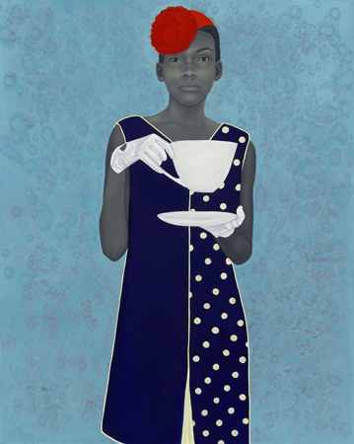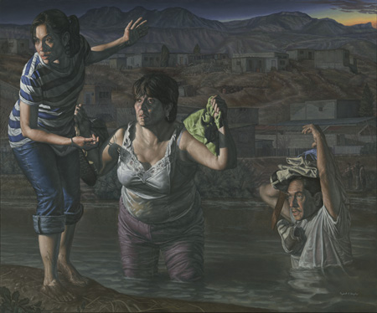

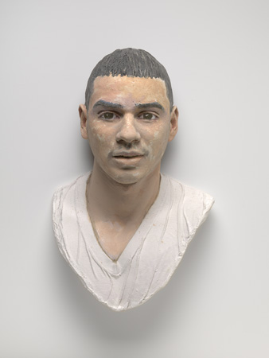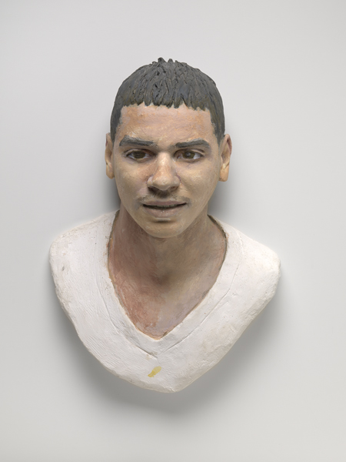

Related Programs and Events (TacomaArtMuseum.org/events)
Lunch and Learn: Carolyn Sherer – Art and Activism through Portraiture
Wednesday, February 1, 12 – 1 pm
Artist Carolyn Sherer’s portrait of Lucy, a transgender 15 year old, is included in The Outwin 2016: American Portraiture Today. Sherer will discuss her experiences as a photographer creating work that confronts social inequity within the culture of the conservative Deep South.
Cost: Free
Curator Conversation: Dorothy Moss, National Portrait Gallery
Saturday, February 4, 3 pm
The Outwin Portrait Competition is one of the most prestigious art competitions in the nation! More than 2,500 artists entered the contest for 2016. How do jurors decide which works are the winners? What makes an individual work stand out among the hundreds of entries? How did the competition begin? Discover the answers to these questions and more with curator Dorothy Moss from the Smithsonian’s National Portrait Gallery.
Cost: $10 general, $5 members and students with ID
Members’ Opening Celebration
Saturday, February 4, 7 – 10 pm
Celebrate the first-ever national tour of our country’s most prestigious portrait competition with the opening for The Outwin 2016: American Portraiture Today. See innovative contemporary works by 43 artists, listen to lively music, get your picture taken, and enjoy appetizers and a no-host bar.
Members’ Opening in-kind support provided by Heritage Distilling Co.
Cost: Free for members: RSVP@TacomaArtMuseum.org; $20 general, $10 students with ID. Purchase tickets at the door.
Portrait Party Free Community Festival
Sunday, March 5, 12 – 4 pm
Get personal with a festival celebrating The Outwin 2016: American Portraiture Today! Snap a photo of a friend for the cell phone portrait competition, practice figure drawing with a live model, create haiku pairings with artwork, and pose for a portrait with a local artist!
Cost: Free
Artist Talk with Amy Sherald, First Prize Winner of The Outwin 2016: American Portraiture Today
Thursday, March 16, 5 – 8 pm, Free Third Thursday
Cost: Free
Teen Night
Saturday, March 25, 7 – 10 pm
TAM’s Teen Art Council brings The Outwin 2016: American Portraiture Today to life at Teen Night, planned by teens for teens. Show off your dance moves, collaborate with friends to make larger-than-life art, snap your best selfie, and more!
Cost: Free with high school ID
List of Artists: 2016 Outwin Boochever Portrait Competition Finalists
John Ahearn, New York City, NY
Dean Allison, Penland, NC
Wendy Arbeit, Emeryville, CA
Rick Ashley, Marblehead, MA
Evan Baden, Albany, OR
Claire Beckett, Jamaica Plain, MA
Claudia Biçen, San Francisco, CA
Kelly Carmody, Waltham, MA
Marti Corn, Houston, TX
Paul D’Amato, Riverside, IL
Ray DiCapua, Storrs, CT
Tim Doud, Washington, D.C.
Maureen Drennan, Brooklyn, NY
* Jess T. Dugan, St. Louis, MO
Gaspar Enriquez, San Elizario, TX
Lucy Fradkin, Staten Island, NY
Jona Frank, Santa Monica, CA
Rigoberto A. Gonzalez, Harlingen, TX
Allison Janae Hamilton, New York, NY
* Jessica Todd Harper, Merion Station, PA
Anne Harris, Riverside, IL
Clarity Haynes, Brooklyn, NY
* Cynthia Henebry, Richmond, VA
* Sedrick Huckaby, Fort Worth, TX
Dave Jordano, Chicago, IL
Riva Lehrer, Chicago, IL
Jarod Lew, Beverly Hills, MI
* Daniel James McInnis, Perrysburg, OH
Michael Meadors, Clayton, NC
Dean Mitchell, Tampa, FL
Thu Nguyen, Honokaa, HI
Tim Okamura, Brooklyn, NY
Christine Osinski, Ridgefield, CT
Paul Oxborough, Excelsior, MN
Louie Palu, Washington, D.C.
* Joel Daniel Phillips, Oakland, CA
Adrián “Viajero” Román, Brooklyn, NY
** Amy Sherald, Baltimore, MD
Carolyn Sherer, Birmingham, AL
Donita Simpson, Royal Oak, MI
Mike Smith, Johnson City, TN
Naoko Wowsugi, Washington, D.C.
Brenda Zlamany, Brooklyn, NY

** First prize winner.
* Denotes artists selected as prize winners.
# # #
Press are invited for a press tour led by the Smithsonian’s National Portrait Gallery curator Dorothy Moss and TAM curator Margaret Bullock.
Thursday, February 2, 11:00 AM
Tacoma Art Museum, 1701 Pacific Avenue, Tacoma, WA 98402.
RSVP for press tour to JVerboort@TacomaArtMuseum.org.
Image Credits, top to bottom, left to right:
Riva Lehrer, Alison Bechdel, 2011. Charcoal, mixed media and 3-D collage on paper, 30 × 44 inches. Courtesy of Sandy Hindin Stone. © Riva Lehrer.
Amy Sherald, Miss Everything (Unsuppressed Deliverance), 2013. Oil on canvas, 54 × 43⅛ inches. Frances and Burton Reifler. © Amy Sherald.
Rigoberto A. Gonzalez, La Guia ("The Guide"), 2014. Oil on linen, 60 × 72 inches. Collection of Matt Gonzalez. © Rigoberto Gonzalez.
John Ahearn, The Rodriguez Twins, 2014. Acrylic paint over plaster (diptych), 19¾ × 13¾ × 7⅜ and 19½ × 12½ × 7½ inches. Collection of the artist. © John Ahearn.
About Tacoma Art Museum
Tacoma Art Museum is an anchor in the city’s downtown and a gathering space for connecting people through art. TAM’s collection contains nearly 5,000 works, with an emphasis on the art and artists of the Northwest and broader western region. The collection includes the largest retrospective museum collection of glass art by Tacoma native Dale Chihuly on continuous view; the most significant museum collection of jewelry by Northwest artists; key holdings in 19th century European and 20th century American art; and one of the finest collections of Japanese woodblock prints on the West Coast. In 2014, TAM welcomed a gift of 295 works of western American art in the Haub Family Collection, one of the premier collections in the nation and the first major western American art museum collection in the Northwest. The Haub gift included $20 million for new galleries and endowed funds. The Haub Family Galleries opened in 2014. In January 2016, TAM announced the gift of the Benaroya Collection, including 225 works of art. The donation also includes nearly $14 million in funding for new gallery space to showcase the collection and an endowment for a dedicated curator and care for the collection. The Benaroya wing is expected to open in fall 2018.
HOURS – Tuesdays–Sundays 10 am–5 pm, Third Thursdays 10 am–8 pm;
Third Thursdays free from 5-8 pm.
ADMISSION – Adult $15, Student/Military/Senior (65+) $13, Family $40 (2 adults and up to 4 children under 18). Children 5 and under free. Members always free.
CONTACT – 253-272-4258, www.TacomaArtMuseum.org, info@TacomaArtMuseum.org

